1. Solar energy
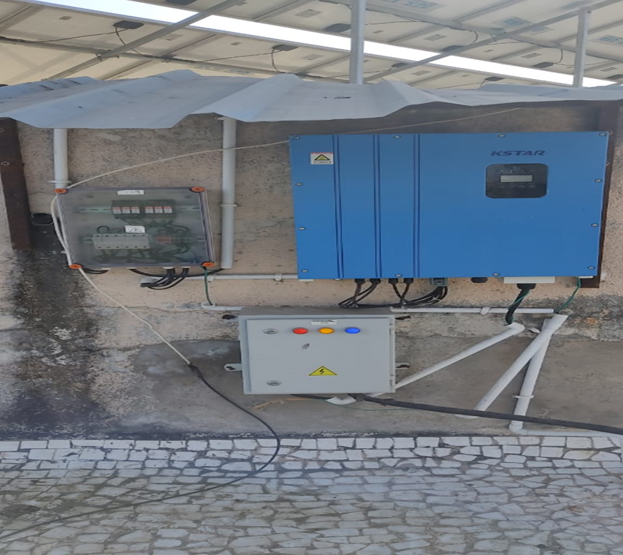
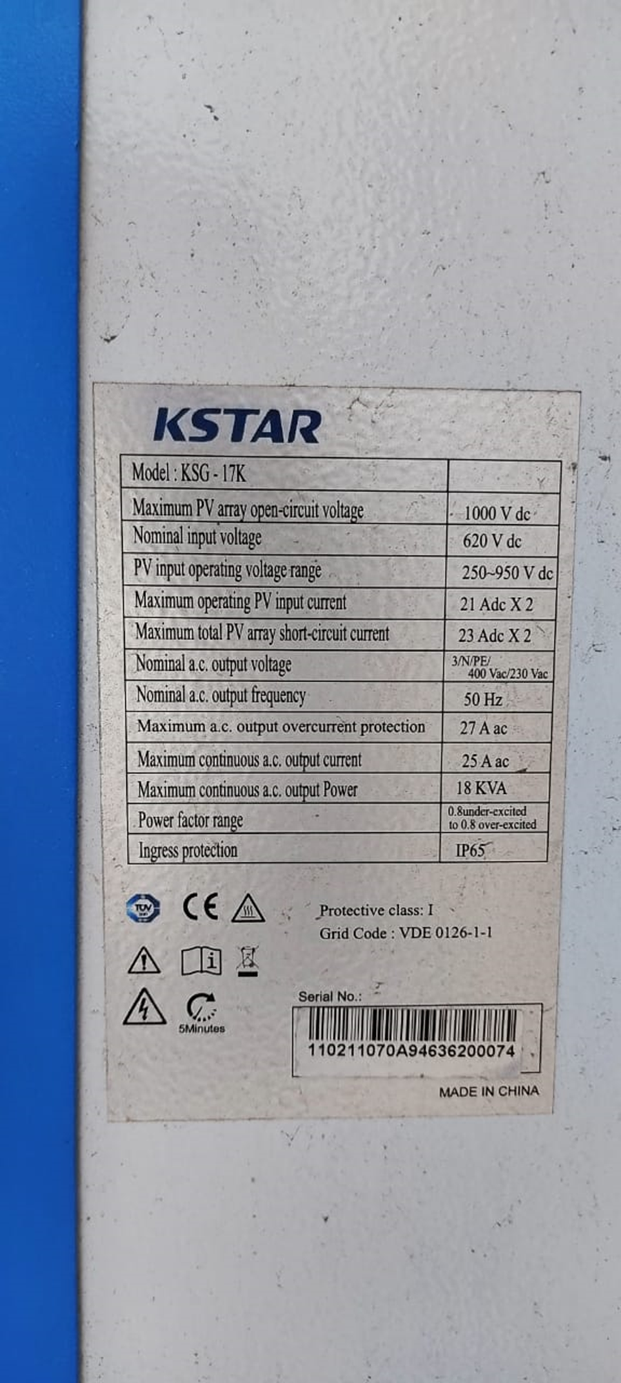

2. Wheeling to the Grid
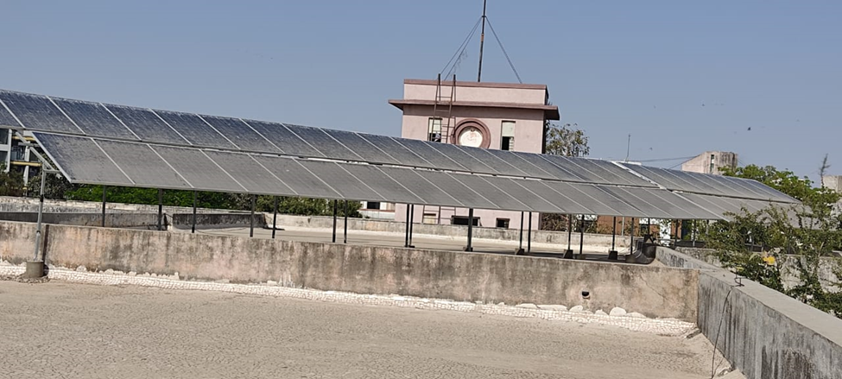

- Use of LED bulbs/ power efficient equipment (more than 80% equipment are LED bulbs/ power efficient equipment)
